Chapter One Tutoring Program
Tutor An At-Risk First Grade Student from Your Computer/Phone

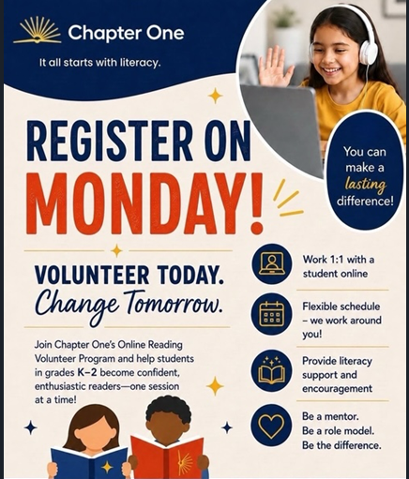

Introduction: Chapter One is the nation’s preeminent online volunteer tutoring program, helping thousands of struggling students learn to read. More than 200 of the country’s most prominent corporations partner with Chapter One to recruit an army of volunteers to help young students in under-resourced schools and communities. A volunteer tutor is paired with a first-grade student for remote 30-minute tutoring sessions once per week throughout the school year. The volunteer may tutor from their office, at home, or wherever there is internet access. During the session, the tutor and student read stories together online and play literacy games that build student word knowledge.

Your commitment: Sessions are during school hours, once a week, for 30-minutes. Volunteers schedule their weekly sessions in the Chapter One platform using a calendar shared with the teacher. You can adjust your session on a daily basis to match openings in your schedule.

Time Frame: Tutoring is expected to begin in the October-November 2026 time frame. Tutoring ends in mid-May 2027.

Registration link: https://app.chapterone.org/register
Volunteer Group: General Atomics – San Francisco

Chapter One information resources are HERE

Background checks are required each year, for new and for returning tutors.
A volunteer is “tutor ready” when they have completed registration, a 30-minute training webinar, and the background check.

Why are we partnering with Chapter One?
Chapter One has shared research that shows if a child is poor reader at the end of first grade, there is an 88% chance that the same child will be a poor reader at the end of fourth grade. In addition, if kids are not reading at grade level by the end of third grade, they are 4x less likely to graduate from high school. Instead of waiting to address literacy issues in the third or fourth grade, the Chapter One program aims to help students read at grade level by the end of first grade – setting students up for reading enthusiasm and scholastic success early on. Teachers have reported that thousands of students have increased reading proficiency, improved student confidence, and fostered a greater love of reading, all thanks to the commitment from Chapter One volunteers.

GA Previous Involvement: GA first participated in the TutorMate program during the 2017-2018 school year. 27 GA&A employees participated in a very rewarding experience by tutoring their students, who were at 3 different schools in the Santa Ana district. 27 employees also participated at 3 classrooms at one school in the Santa Ana district during the 2018-2019 school year. TutorMate began again with 25 tutors during the 2019-2020 school year, but the program ended prematurely in March 2020 due to COVID-19. COVID-19 prevented any programs in 2020-2021. There were 17 tutors for both the 2021-2022 and 2022-2023 school years who worked with students from Denver area schools. In 2023-2024 and 2024-2025, about 20 tutors worked with students from the New Haven School district in Union City, CA. In 2025-2026, about 17 tutors worked with schools in Atlanta.

2026-2027 School District: GA employees will work with schools in Texas.

Charging your time:
Participation in this program is entirely voluntary. If you decide to participate in this program, you may apply to use a charge number provided by the GA Sciences Education Foundation GASSSS program for up to 9 hours in calendar year 2026 (the equivalent of 18 30-minute tutoring sessions). You can also apply for support in calendar year 2027 for an additional 9 hours. Note that the GASSSS program provides a total of up to 9 hours of support per employee per calendar year for STEM related activities.
To apply to use the GASSSS charge number, please fill out a GASSSS application form at: http://www.sci-ed-ga.org/gassss

Participants are typically paired-up with an individual student for the duration of the school year, and engage in one 30-minute session with such student each week until the conclusion of the school year. If the number of anticipated weekly sessions during a school year exceeds the amount of time chargeable to the GASSSS-provided charge number, participants should expect to participate in those sessions on their own time.

Using your company computer and phone:
You should expect to use your company computer and phone to participate in this program. These uses are approved and allowed.

Program support: The GA Sciences Education Foundation is funding the implementation of the Chapter One tutoring program at GA.

For additional information: Contact the GA Chapter One coordinator, Larry Woolf, at: Lawrence.Woolf@ga-asi.com

